Student Name: Yuyang Gong Student Number: 49079984 Team Name: FriendZone
Week: 5
Title: Storyboarding a Care-Centred Social Journey

Description:
We created a storyboard around a newcomer entering Brisbane, selecting interests and joining a small local circle. The journey included discovery, a low-pressure message, an organised activity and mutual follow-up. This made the service understandable as a sequence rather than a collection of features.
At the same time, we considered privacy, consent, safety, inclusion and the risk of turning friendship into measurable performance. The proposal therefore emphasised small circles, user choice and gradual participation. Rewards were treated as light encouragement rather than public competition, although we recognised that this assumption still required testing.
Visual Evidence:
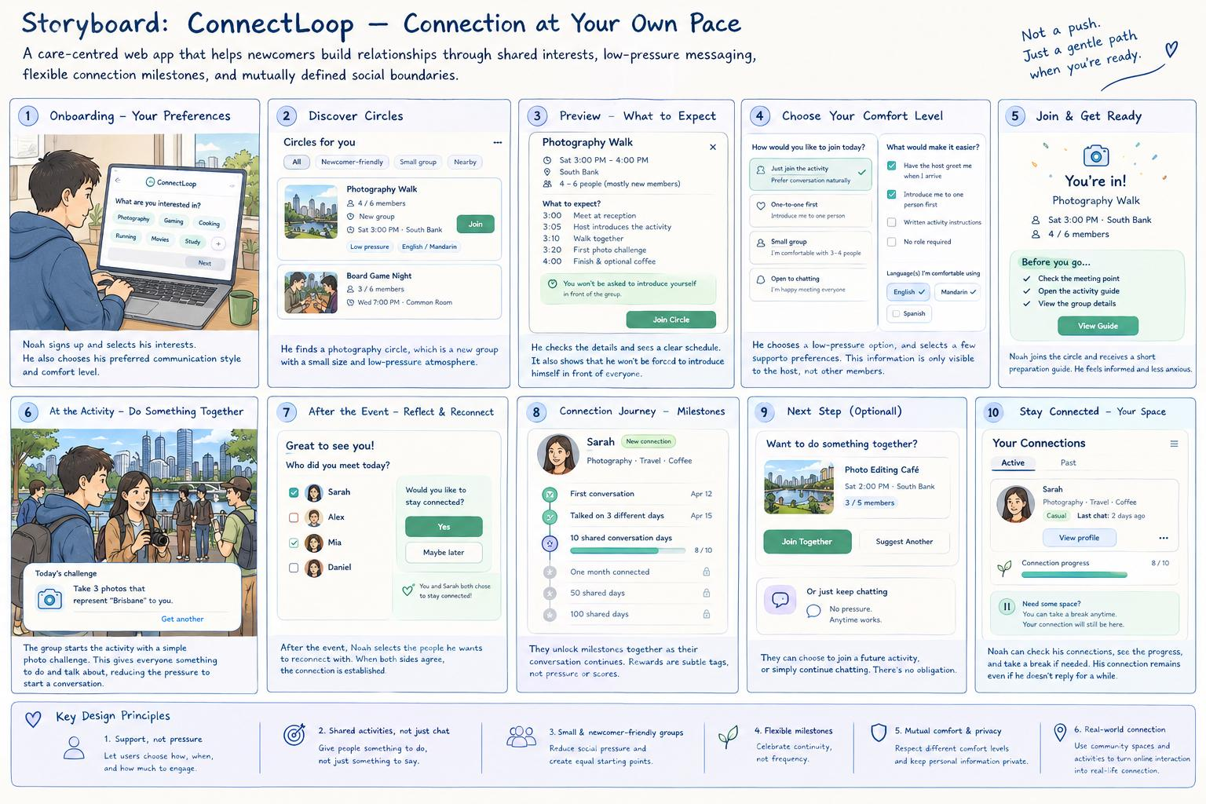
Early storyboard showing a newcomer moving from discovery to local connection.
Statement on Learning:
I learned that ethics changes the interaction itself. Protecting vulnerable users is not an extra checklist added after design; it affects what information is collected, how much control users have and whether prompts feel supportive or manipulative. Storyboarding helped reveal these ethical decisions at each stage of the journey.

